Exp.No:40
40. Draw Rectangular shape and extract objects.

Aim:
To draw a rectangular shape around an object and extract the selected object from an image using OpenCV.
Procedure:
- Read the input image.
- Select the coordinates of the object.
- Draw a rectangle around the object.
- Crop the rectangular region.
- Display the selected object.
- Save the rectangle image and extracted object.
Program:
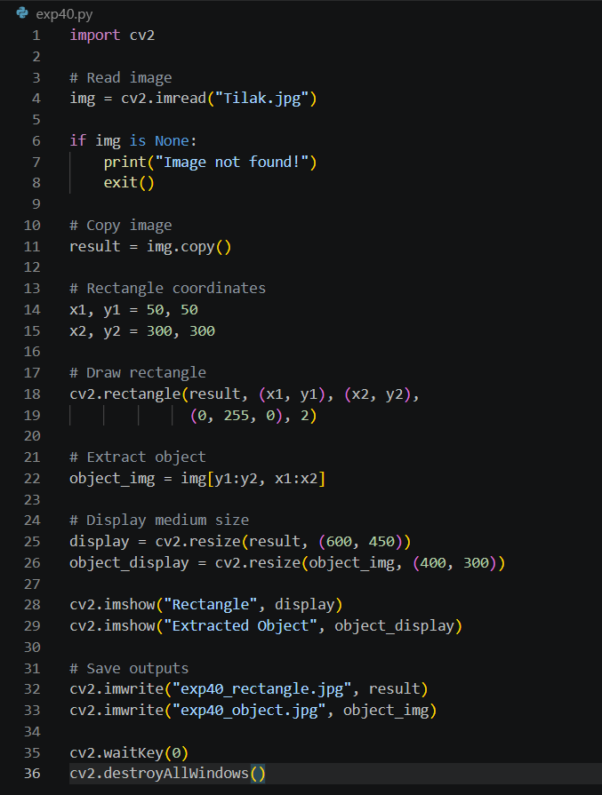

Input:
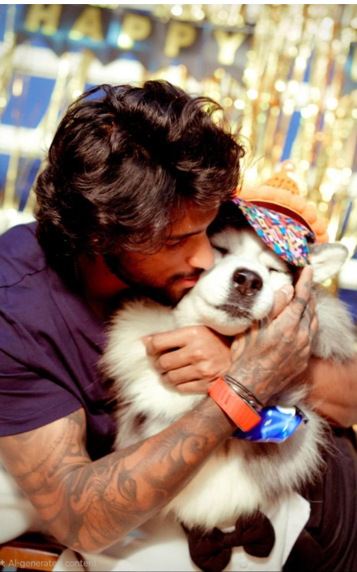

Output:
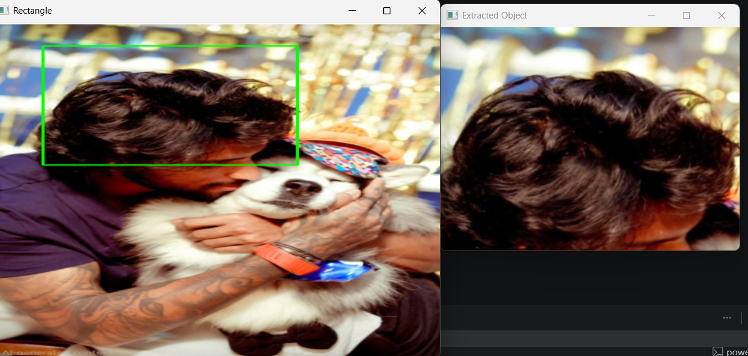

Result:
The rectangular region was successfully drawn and the selected object was extracted from the image using OpenCV.

